**Third Star Financial – Enterprise Data Management Architecture and Implementation Plan**

Matthew W Schnorr

4/25/2021

**Third Star Financial – Enterprise Data Management Proposal and Implementation Plan**

**Introduction**

Third Star Financial is in the business of money transfer and related services, with a primary customer base of what would be considered unbanked or transient users. Opened in 1969, there are 15,000 locations worldwide where customers can interact, or they can use our online service to conduct their business. Third Star has grown primarily through acquisitions since inception, and at the peak of operations had 24% of the market share. However, business has dropped by nearly a quarter over the past several years and we now currently sit at 18.1% market share as numerous competitors have eaten away at our customer base. Several executives have recently left for these competitors, so now is the time to assess where we are at and where we want to go as a company.

The area of focus of this proposal centers on enterprise data management and the benefits that can be gained by having a master data management architecture and framework for business rules, processes, and information. This proposal will assess the current state of Third Star. It will also provide a view of a future state where we can minimize obstacles and problems and maximize profitability and solutions for the foreseeable future. We will accomplish this by providing data management solutions via multiple scales and scopes as well as a plan to implement them.

**Current State Summary and Evaluation of Current Components**

Currently, the data and technology structure at Third Star resembles more of a jigsaw puzzle of systems and warehouses assembled through acquisitions instead of a comprehensive company-wide system. While this is not unusual for a company that has grown primarily via acquisitions, the time has come to put an emphasis on improving this area.

From a technical perspective, Third Star runs a collection of software throughout its various channels, including database management systems from both Oracle and MS SQL (Unix/Linux and Windows). The company hardware is provided by IBM and HP. And there are a great deal of bandwidth and network issues since there is no central network architecture. None of the systems are integrated, and there are several data warehouses that exist (in various stages of development), but all are siloed. In addition, there are no data mining or dashboard capabilities, and no mobile app exists at the current time.

From a staffing perspective, the IT department has been assembled through the various acquisitions and mergers the company has experienced. Most of these technical experts are only proficient in the systems they were familiar with before acquisition. Many of the lines of business have developed their own small groups of tech experts as there is little faith in the central IT department, as they have not proved to be proficient. Also, at the current time, there is no metadata management, including no management of business rules or definitions.

The current situation at Third Star is by no measure optimal. When comparing the status at Third Star with the benefits a strong enterprise data architecture can provide as listed in the DAMA DMBOK guide, it is easy to see there are large gaps where improvements need to be made. Because there is no integration or alignment with strategy, there are large risk possibilities from any imaginable perspective. In addition, there is the cost of missed business opportunities due to sub-optimal levels of architecture and data management.

The substandard enterprise data management system is the main driver of the lost market share for the business. Staff turnover, the chaos and confusion of not having an integrated system, data mining capabilities, reporting dashboards for management, and an app-based interface has caused other companies to capitalize in these areas and erode customer loyalty to Third Star. A strong focus in this area with a detailed implementation plan will be critical to turning the trend of customer loss around.

**Data Modeling**

Conceptual Model Logical Model

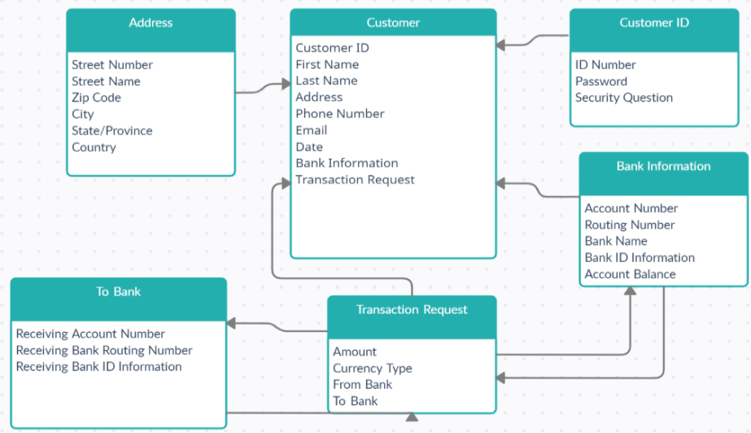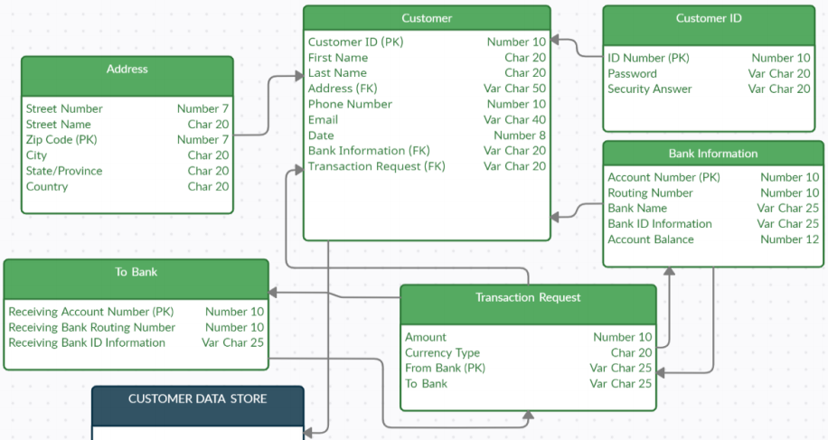

From a customer interaction perspective, I have developed both a conceptual and logical data model. “The **main difference** between conceptual and logical data model is that **conceptual data model represents entities and their relationships, while logical data model provides more details including attributes in addition to entities and the relationships” (Lithmee 1).** If the proposed models are developed, efficiency and data collection processes will be improved. The improved design will capture appropriate and necessary customer information and normalizing the collected data will provide data analysts the ability to gain insight to our customer base.

This customer centric model will give insight into channel usage, geographical areas of importance from a company perspective, and so forth. By standardizing the process through one system, the noise of converting all the data from other systems from integration will be reduced, meaning insight gains will become more agile and impactful.

**Recommendations** To get to where they need to be from a technological standpoint, Third Star must undergo a major change in the entirety of its infrastructure. The main object of their focus should be implementing a holistic master data management system to take the place of all their patchwork systems acquired through integration activities. My recommendation would be IBM Infosphere. In addition, a robust analytical and reporting solution that is scalable will be a necessity. With an array of options being available, my first choice is Tableau as its commonly used worldwide.

Some of the most applicable benefits to Third Star would be eliminating data redundancy, ensuring a high level of security and privacy, as well as being able to handle massive volumes of information on a global scale. “The huge effort involved in the digital handling of a company’s entire data means that data management systems will be indispensable tools for saving time, streamlining processes and making better use of all of your company's resources” (Munoz 1).

The biggest challenges that come to mind when initiating these changes is twofold. First, the cost is going to be immense. The purchase of the programs and the labor cost of installation and migration of entire business systems and rules will be significant. The second challenge will be employee driven. This will cause a disruption of job roles and will eliminate some jobs and require different roles to be created and filled. This will result in even more turnover in the short term. Required training for success will also drive a large cost but will be a requirement as there is no point in implementing a program if it is not going to be used, or at the very least used appropriately.

Recommendations for Future State Data ManagementWhen referencing the industry guide as set forth by DAMA (The Data Management Body of Knowledge), there are several recommendations to be made on the current state of Third Stars Data Management. In addition to the implementation of a master data management system, there are some procedural data changes that need made, specifically regarding reference data sources, business intelligence management, and data quality.

The biggest impact that can be made, in my opinion, is the process around data collection, cleaning, and analyzing to gain insight for future activity. While the architecture framework and security are vital and act as the backbone, the goal is to use data to gain a competitive advantage and help drive business activity. Due to the current inefficiencies due to multiple systems, lack of customer use interfaces, and the lack of expertise in both IT and data analysis, there is plenty of room for improvement.

These changes should impact management strategy if the management structure is willing and capable of embracing change management across the organization. By implementing a new data management system, analytical tools, and better customer interaction portals, the company can produce an accurate and streamlined set of data, as well as ensuring the appropriate parties have access to such data and can use it to make future business decisions. Information will be more readily available and much closer to real time, so the management team can be agile and make data driven decisions to improve their results. The biggest need of management is fostering a culture of change. This must begin from the top down in the organization, and everyone must buy in for the changes to work.

Regarding customers and shareholders of the company, both groups should be impacted positively in the long term. The customers will have a more robust model of interacting with the company with mobile application. They should also feel more confident in the company knowing their confidential information is much more secure. Shareholders will of course see some up-front expense, but in the long run should see higher levels of profitability as market share is regained.

Ethical Considerations

Ethical considerations must be intertwined throughout the process from start to finish. When dealing with data and personally identifiable, confidential information, ethics must be at the forefront of every decision the company makes. Just because information is accessible, restraint must be shown at times and not allow all business decisions to be driven from a purely financial standpoint.

**PLAN FOR IMPLEMENTATION**

Assuming the decision is made to pursue my recommended technological changes, a plan must be put into place to ensure success for the implementation, roll out, and integration. The plan must contain four main sections. First, there is the strategy and planning phase where all the pieces and parts, timelines, and task assignments are laid out. All project team members “should be prepared to have a detailed discussion around project overview, requirements and associated timing/milestones, also known as the project baseline. All team members should discuss what a successful change looks like and assign change management roles” (Witt 1). Here, we are focused on the complete roll out of Infosphere and Tableau.

Once that is complete, you move on to the next step of configuration and testing. It is here that pilot processes are followed, and sample testing is done. Before the full-scale changes are made, it is crucial to work out as many kinks as possible. A full-scale company change requires in-depth testing in advance. This will also include beta activities and focus group changes involving streamlining and ingesting legacy systems into the new MDM process.

Next there is product training. In a massive scale roll out such as this, the training piece is of critical importance. Focused training must be developed for each user role and delivered in a timely fashion. Activities such as breaking the changes into small steps, hosting lunch and learns, assigning mentors, and engaging the employees every step of the way through interactivity and with a follow up plan in place will lead to success (Forbes 2).

Finally, comes the communication and full roll out. It is here that the managers from the top of the house down must be fully committed and engaged with their public employee engagements. They must demonstrate and be completely bought into the change and hold everyone accountable to the new activities and processes. While each level of management will have a different level of expertise, all levels of the management change must remain lock step in their approach.

**FINANCIAL AND ETHICAL STANDARDS**

Third Star is a company that deals heavily in consumer information. While this can be a huge source of benefit to a company, providing a treasure trove of viable information, there is also risk and large privacy concerns that must be accounted for. “Integrating customer information in an MDM Data Hub supports enterprise-wide customer-centric transformations that in turn create significant competitive advantages for the enterprise. At the same time, however, precisely because an MDM system integrates master data, including customer data, in one place called a “Data Hub,” these implementations face significant security and compliance risks” (Enterprise Data Management 59).

One of the frameworks that must be put into place is how to protect personally identifiable and other confidential information. The approach that I would recommend for Third Star would be based on the International Data Privacy Principles. There are 13 main points to the principles that must be accounted for. I would build the company framework around these principles, focusing on six of them. From a high-level synopsis, they are categorized and listed as follows: Comply with national data protection or privacy law, comply with current security standards, implement an easily perceptible, accessible, and comprehensible privacy policy and mandate employees to follow the policy, do not use or divulge any customer data except in house for business purpose only, do not collect customer data if such collection is unnecessary or excessive, and announce data breaches relating to sensitive data. Also, country specific regulations like the US sets forth with the FTC or the Canadian Privacy laws must be adhered to. Ethics for a company can be murky to define and hold others accountable to. This has been the case for as long as humanity has been involved in these types of operations as everyone has a different set of standards and guiding principles they believe in, as well as how they interpret them. “There are two types of ethics: compelled ethics and imposed ethics. Compelled ethics are those that are part of an internal personal code of responsibility. Imposed ethics are those forced on us by law or regulation” (DMBOK 354). Imposed ethics are much easier to interpret and hold people accountable to, whereas compelled ethics provide room for interpretation.

From a business perspective, ethics should be everyone’s responsibility, and should be interwoven with every business process and decision. “Business data consumers are not solely responsible for ethical breaches; data management professionals play an advisory role in the ethical use of data. Ethical handling of data includes a legal framework, activities involving dataset handling, and the framing of the questions of analysis without bias” (DMBOK 354). Ethical standards and activities build trust and provide longevity to a company.

For Third Star, I would strongly recommend implementing a company-wide “Code of Conduct” that would be disbursed and reviewed by all employees on an annual basis at minimum. Ensuring every individual has access to the correct entitlements for data viewing and use helps minimize the amount of ethics that can be impacted, as the information can be tempting for employees to break their ethics for. This information could be obtained and sold to an outside source for individual financial gain, so tight data security in this area is of paramount importance. Also, following the ethics risk model of identifying individuals, capturing the necessary behaviors, profiling possible transactions, then granting or denying access is a proven way to help maintain ethical behavior, albeit not fully controllable.

**Conclusion**

In conclusion, Third Star can return to a market leader in the industry. However, that will require major expense in both time and money. By selecting and implementing one MDM system and a visualization/reporting tool, and then migrating from all legacy systems and processes to the proposed tools and processes, Third Star will have a bright future state. Other tools and processes can be added later (such as Hadoop and SQL), this is just the initial step.

If Third Star chooses to take a customer centric approach as displayed with my data models and follows the structures and guidelines as set forth by the DAMA-DMBOK guide referenced several times in this proposal, the company will have chosen a standardized and time-tested framework for success.

**REFERENCES**

“An Ethical Approach to Data Privacy Protection.” *ISACA*, www.isaca.org/resources/isaca-journal/issues/2016/volume-6/an-ethical-approach-to-data-privacy-protection

Council, Forbes Human Resources. “Council Post: Nine Ways To Help Employees Adapt To New Company Technology.” *Forbes*, Forbes Magazine, 1 Mar. 2018, [www.forbes.com/sites/forbeshumanresourcescouncil/2018/03/01/nine-ways-to-help-employees-adapt-to-new-company-technology/?sh=4496a24252dd](http://www.forbes.com/sites/forbeshumanresourcescouncil/2018/03/01/nine-ways-to-help-employees-adapt-to-new-company-technology/?sh=4496a24252dd).

:DMBoK - Data Management Body of Knowledge.” *DAMA*, 20 Oct. 2020, www.dama.org/cpages/body-of-knowledge.

*Enterprise Data Management*. Edited by ACAD Studies, Southern New Hampshire Univ COCE-Online, 2020.

Lithmee. “What Is the Difference Between Conceptual and Logical Data Model.” *Pediaa.Com*, 15 July 2019, pediaa.com/what-is-the-difference-between-conceptual-and-logical-data-model/#:~:text=The%20main%20difference%20between%20conceptual%20and%20logical%20data,keys%20other%20than%20the%20entities%20and%20the%20relationships.

Muñoz, Alma. “Types of Data Management (DM) Tools.” *Sales Layer Blog*, blog.saleslayer.com/types-data-management-tools#:~:text=%20Types%20of%20Data%20Management%20tools%20%201,in%20order%20for%20it%20to%20be...%20More.

“Top 16 Master Data Management Software in 2021 - Reviews, Features, Pricing, Comparison.” *PAT RESEARCH: B2B Reviews, Buying Guides & Best Practices*, 15 Mar. 2021, [www.predictiveanalyticstoday.com/top-master-data-management-software/#:~:text=Top%2016%20Master%20Data%20Management%20Software%201%20Ataccama.,...%2010%20Agility%20Multichannel.%20...%20More%20items](http://www.predictiveanalyticstoday.com/top-master-data-management-software/#:~:text=Top%2016%20Master%20Data%20Management%20Software%201%20Ataccama.,...%2010%20Agility%20Multichannel.%20...%20More%20items)...

“Types of Data Models: Conceptual, Logical & Physical.” *Erwin, Inc.*, 11 Dec. 2020, erwin.com/blog/types-of-data-models-conceptual-logical-physical/.

Witt, Emily. “The 4 Phases of an Effective Change Management Plan [Full Guide].” *Convercent*, 26 Feb. 2021, www.convercent.com/blog/4-phases-of-an-effective-implementation-and-change-management-plan.